
- Project title : Modern Expense Tracker
- Course title : Programming in Python
      - Course code : CSE 2006
      - Course type : Flipped course
      - Course credits : 3
      - Professor : Dr. E Nirmala
      - Slot : A11+A14+D11+A12+D12+A13
      - Submitted by : Sanjay Kumar
      - Registration number : 26BCY10094
- Submission date : 30/09/2026
INTRODUCTION :
The Modern Expense Tracker is a lightweight, menu-driven Python application designed to record, store, display, and summarize personal expenses. It provides a simple command-line interface through which users can enter an amount, category, and optional description for each expense. Each record is automatically associated with the current date and time.
The application uses JSON file storage so that expense records remain available between program executions. It also provides a summary that calculates total lifetime spending and category-wise spending percentages. The project demonstrates practical Python concepts including functions, lists, dictionaries, file handling, JSON processing, exception handling, user input validation, and date-time processing.
PROBLEM STATEMENT :
Tracking daily expenses manually can make it difficult to maintain organized records and understand spending patterns. Users need a simple system that can accept expense details, store them reliably, display previous records, and provide a basic spending summary without requiring a complex financial application. The Modern Expense Tracker addresses this need through a local Python-based command-line solution.
PROJECT OBJECTIVES :
- To develop a simple command-line expense tracking application using Python.
- To allow users to enter and categorize individual expenses.
- To store expense records permanently using a JSON file.
- To display all recorded expenses in a structured format.
- To calculate total spending and category-wise spending percentages.
- To demonstrate practical use of Python functions, data structures, file handling, and exception handling.
FUNCTIONAL REQUIREMENTS :
1. User-System Interaction
- The system displays a menu with options to add an expense, view all expenses, view a summary, or exit.
- The user selects an operation by entering a menu number from 1 to 4.
2. Data Input
- Accepts a numeric expense amount from the user.
- Accepts a category such as Food, Transport, Bills, or Entertainment.
- Accepts an optional description.
- Automatically records the current date and time.
3. Input Validation
- Rejects amounts that are not numeric.
- Rejects amounts less than or equal to zero.
- Uses General when the category is empty.
- Displays a clear message for an invalid menu option.
4. Data Processing & Storage
- Represents each expense as a Python dictionary containing amount, category, description, and date.
- Stores all expense dictionaries in a Python list.
- Writes the list to expenses.json using JSON.
- Loads existing expense data when the application starts.
5. Output and Analytics
- Displays stored expenses with date/time, category, amount, and description.
- Calculates total lifetime spending.
- Calculates category-wise totals and percentages.
NON-FUNCTIONAL REQUIREMENTS :
1. Usability
- Simple menu-driven command-line interface.
- Clear prompts and messages.
2. Reliability
- Handles missing JSON files by starting with an empty list.
- Handles invalid JSON during loading.
3. Maintainability
- Separate functions handle loading, saving, adding, viewing, summarizing, and overall control.
- Modular structure makes functions easier to understand and modify.
4. Data Persistence
- Expense information is stored locally in expenses.json.
- Saved data can be loaded during later executions.
5. Resource Efficiency
- Uses lightweight standard Python modules.
- No external database is required for the core application.
SYSTEM ARCHITECTURE :
- Presentation Layer: Displays the menu and receives keyboard input.
- Data Loading Layer: Reads existing records from expenses.json.
- Validation Layer: Checks expense amounts and menu choices.
- Expense Processing Layer: Creates and appends expense dictionaries.
- Storage Layer: Serializes expense data to JSON.
- Analytics Layer: Calculates total and category-wise spending.
- Output Layer: Formats and displays records and summaries.
DESIGN DIAGRAMS :
1. Workflow
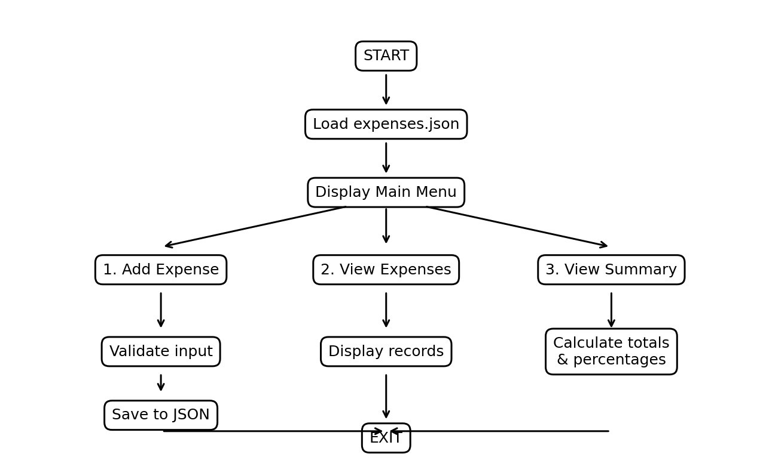

↓
[start]
↓
[Load expenses from JSON]
↓
[Display Main Menu]
↓
[Add Expense] → [Validate] → [Save JSON]
↓
[View Expenses] / [View Summary]
↓
[Exit]
2. Data Flow Architecture
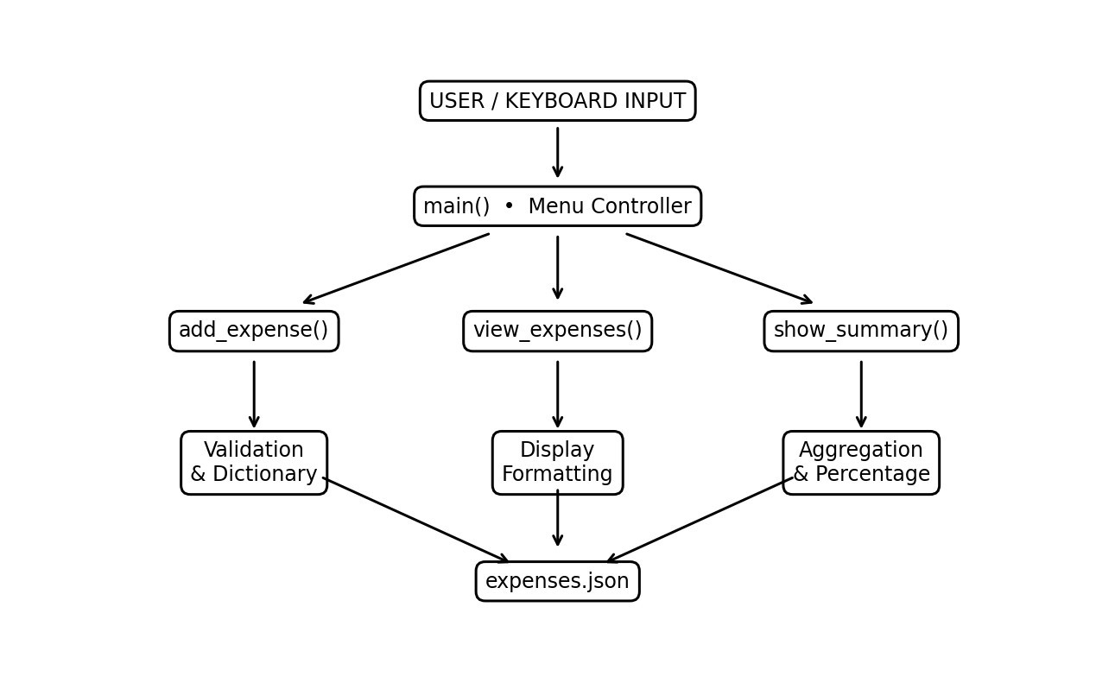
- Input Stage: Captures amount, category, and description.
- Validation Stage: Checks amount format and positive value.
- Record Stage: Creates the expense dictionary.
- Storage Stage: Saves the complete list in JSON.
- Analytics Stage: Aggregates spending by category.
- Presentation Stage: Displays records and calculated results.
3. Component Breakdown
- load_expenses(): Loads stored JSON data.
- save_expenses(expenses): Saves the expense list to JSON.
- add_expense(expenses): Collects and validates expense information.
- view_expenses(expenses): Displays all expense records.
- show_summary(expenses): Calculates spending statistics.
- main(): Controls the menu and program flow.
DESIGN DECISIONS & RATIONALE :
- Programming Language: Python
Rationale: Python provides simple syntax and built-in modules suitable for a beginner-friendly data management application.
- Interface Paradigm: Command-Line Interface
Rationale: A command-line interface keeps the project lightweight and focuses on programming logic and data processing. 3. JSON-Based Storage
Rationale: JSON provides a simple human-readable structure for storing expense dictionaries without a separate database server. 4. Modular Function Design
Rationale: Separating operations into functions makes the program easier to read, test, debug, and extend.
5. Category-Based Analytics
Rationale: Grouping expenses by category helps the user understand spending distribution.
IMPLEMENTATION DETAILS :
- Language: Python 3
- Development Environment: Python IDLE / Visual Studio Code / Terminal
- Source File: Sanjay.py
- Data File: expenses.json
- Primary entry point: main()
FUNCTION IMPLEMENTATION :
- load_expenses(): Checks whether the data file exists and loads JSON records.
- save_expenses(expenses): Writes records using json.dump().
- add_expense(expenses): Reads, validates, creates, and saves an expense.
- view_expenses(expenses): Prints a formatted table of records.
- show_summary(expenses): Calculates total and category percentages.
- main(): Displays the menu until Exit is selected.
DATA STRUCTURE :
Each expense is stored as a dictionary with amount, category, description, and date. Multiple dictionaries are maintained in a list and serialized to JSON.
SAMPLE RECORD :
{
"amount": 250.0,
"category": "Food",
"description": "Lunch",
"date": "2026-09-29 15:30"
}

TESTING APPROACH :
- Input Testing: Tested numeric and non-numeric amount entries.
- Boundary Testing: Tested zero and negative amounts.
- Category Testing: Tested normal and empty categories.
- Storage Testing: Tested saving and loading through expenses.json.
- Display Testing: Verified required record fields are shown.
- Summary Testing: Verified total and category percentage calculations.
- Menu Testing: Tested valid options 1–4 and invalid choices.
- Empty Data Testing: Verified suitable messages when no expenses exist.
SAMPLE OUTPUT :
=== MODERN EXPENSE TRACKER ===
- Add Expense
- View All Expenses
- View Summary & Analytics
- Exit
--- Add New Expense ---
Enter amount ($): 250
Enter category: Food
Enter description: Lunch
Successfully added $250.00 under Food.
CHALLENGES FACED :
- Handling Invalid Input: Non-numeric amounts require ValueError handling.
- Persistent Storage: Records must be saved correctly for later use.
- Maintaining Data Structure: Every record must contain consistent fields.
- Category Aggregation: The summary must combine amounts by category.
- User-Friendly Output: Records and summary values must be clearly formatted.
OUTPUT :
The program produces three major user-facing outputs: an expense-entry confirmation, a table of stored expenses, and a summary containing lifetime spending and category-wise percentages.
LEARNINGS AND KEY TAKEAWAYS :
- Learned to divide a Python application into reusable functions.
- Gained practical experience with lists and dictionaries.
- Learned JSON file handling for persistent local data.
- Applied exception handling to manage invalid user input.
- Used datetime to record when an expense was added.
- Learned aggregation and percentage calculations for spending analytics.
- Understood the importance of validation and clear user feedback.
FUTURE ENHANCEMENTS :
- Add edit and delete operations.
- Add weekly, monthly, and yearly reports.
- Add graphical charts.
- Add budget limits and spending alerts.
- Add a graphical user interface.
- Replace JSON storage with SQLite for larger datasets.
- Add search and date/category filtering.
CONCLUSION :
The Modern Expense Tracker demonstrates how Python can be used to build a practical personal expense-management application. The project combines user input, validation, modular functions, data structures, JSON file handling, date-time processing, and basic analytics in a lightweight program.
The application provides the core operations required for recording expenses, viewing stored records, and understanding category-wise spending. Its modular design provides a foundation for future improvements such as graphical interfaces, database storage, budgeting, and advanced reporting.
PROJECT SOURCE CODE :
The implementation is contained in the submitted Python source file Sanjay.py. It defines data loading and saving, expense entry, expense display, summary calculation, and menu-driven program flow.
REFERENCES :
- Python Software Foundation – Python Documentation.
- Python Standard Library Documentation – json module.
- Python Standard Library Documentation – os module.
- Python Standard Library Documentation – datetime module.

